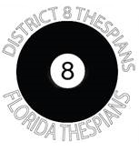
INDIVIDUAL EVENTS FESTIVAL

CATEGORY PERFORMERS IN EVENT ENTRY PER TROUPE

Monologue 1 3
Duet Acting 2 3
Ensemble Acting 3-16 2
Solo Musical 1 3
Duet Musical 2 3
Small Group Musical 3-7 2
Large Group Musical 8-16 2
Pantomime 1-8 3
Playwriting 1-2 2
Scene Design 1 5
Costume Construction 1 5
Costume Design 1 5
Publicity Dire3ctrion 1 5
Make Up Design 1 5
Student Choreography 1 5
Student Directed Scenes 1 2

